Where we should be when we are serving:

If the other team sends us a free ball, where we should transition to:

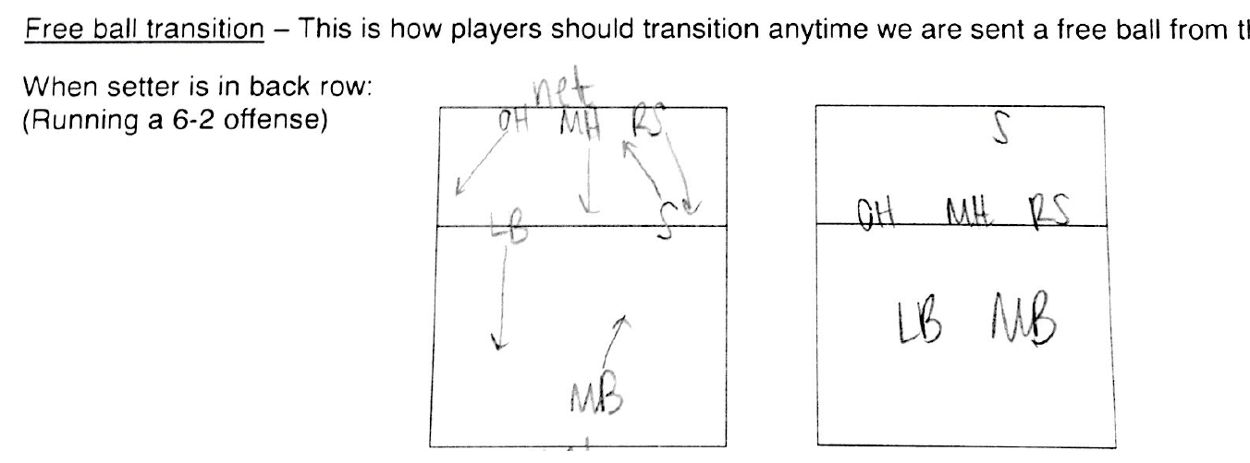

Serve Receive:

When the other team is serving the ball, here is how we should be set up in each rotation:

